1. When we have two or more tranforms back to back, then go for Option Chaining.
2. Following is the example where using two different transformation specs which we will combine into one spec.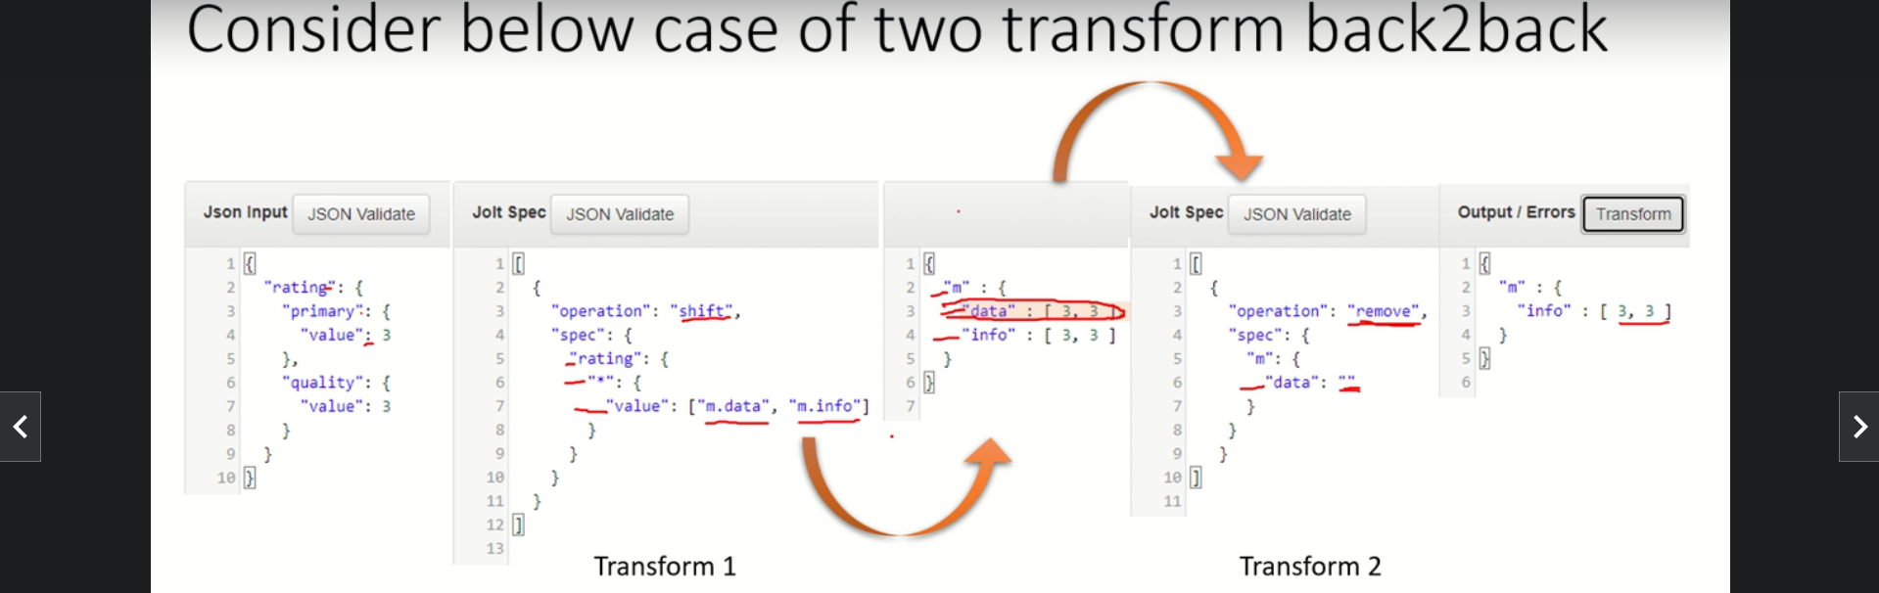
3. Below is the example where one spec and two operations back to back.